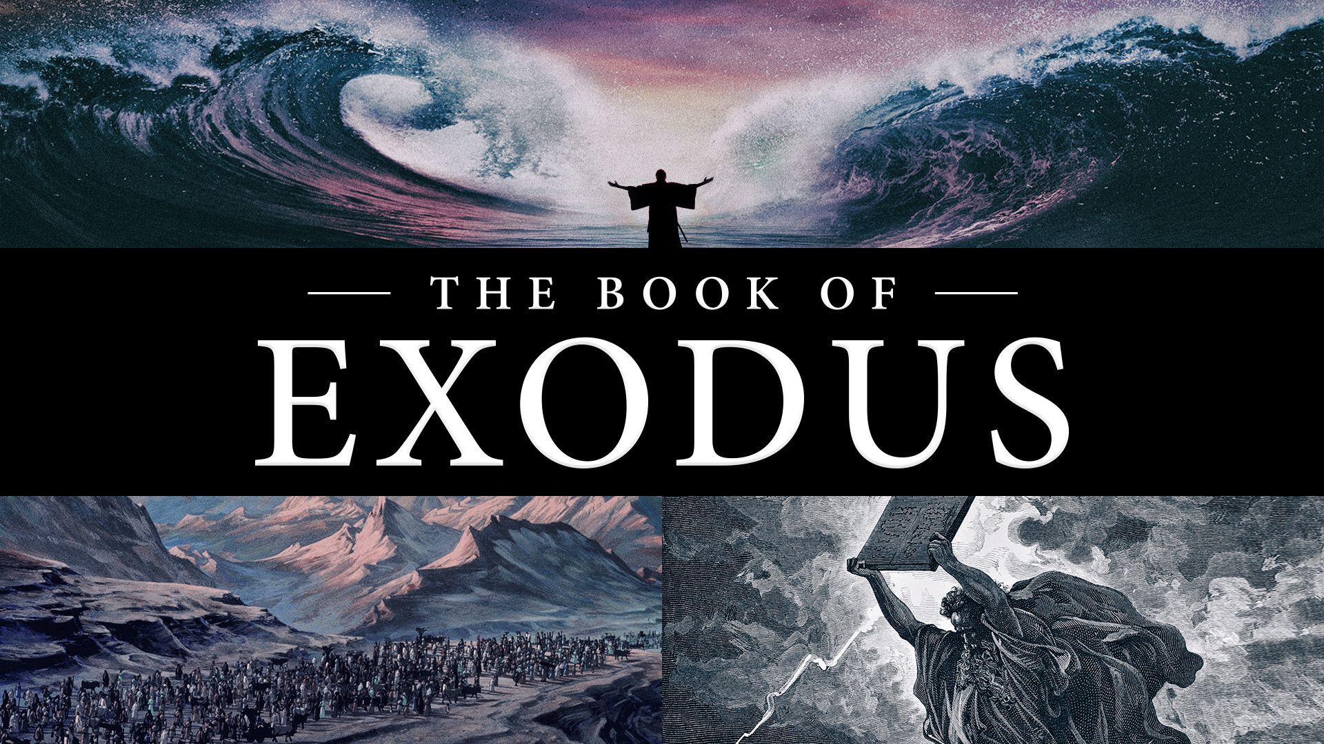

An overview study of some of the
Greatest Themes In Scripture

13 Weeks - Open to the Public
At the Northeast church auditorium,
Sundays at 9:30AM, Oct-Dec. (2022)

Exodus Class Outline
The goal of this class is for every student to become familiar with the book of Exodus and some of the principles that can be learned from this great part of God’s Story. It is not intended to be an in-depth look at all the issues. Instead, we’ll primarily ask, ‘What does this story teach about God?’ To answer that question, we need to first ask, ‘What could this story mean to the original audience?’ As always, feel free in class to ask any questions you have about the text. And then finally, we’ll try to discern where these Exodus themes occur in the NT and make practical applications to our daily lives. Join us on the journey! Come prepared to answer in class so we can learn along with you.
Oct 2 1) Intro To Exodus (Watch Bible Project Video)
Oct 9 2) God Hears Israel’s Cry Ch 1-2
Oct 16 3) YHWH Sends Moses Ch 3-6
Oct 23 4) The Plagues Ch 7-11
Oct 30 5) The Passover Ch 11-13
Nov 6 6) Crossing The Sea Ch 14-15
Nov 13 7) Journey to Sinai Ch 16-18
Nov 20 8) The 10 Commands Ch 19-20
Nov 27 9) The Book of the Covenant Ch 21-24
Dec 4 10) Tabernacle Instructions Ch 25-31
Dec 11 11) Rebellion & Forgiveness Ch 32-34
Dec 18 12) Tabernacle Completed Ch 35-40
Dec 25 13) Conclusion & Review

Oct 2 1) Intro To Exodus (Watch Bible Project Video)

1) Summarize the book of Exodus? Who is the audience?

2) How can Exodus be outlined?

3) What aspects of God can be seen in The Exodus?

4) What major characters and events appear in Exodus?

5) How is Jesus foreshadowed in The Exodus?

6) What else should people today know about Exodus?

Oct 9 2) God Hears Israel’s Cry Ch 1-2
1) Summarize this week’s chapters.

2) What would these stories mean to the original audience?

3) What do we learn about God in these chapters?

4) How could these verses impact our daily lives as Christians?

5) What do you think about the mid-wives? What are possible lessons for us?

6) How would you describe Moses’ behavior in Ch 2?

7) What foreshadows of the NT are found in these chapters?

Oct 16 3) YHWH Sends Moses Ch 3-6
1) Summarize this week’s chapters.

2) What would these stories mean to the original audience?

3) What do we learn about God in these chapters?

4) How could these verses impact our daily lives as Christians?

5) How would you describe Moses’ conversations with God Ch 3-4?
What are the possible lessons for us?

6) How does God answer Moses in Ch 6?

7) What foreshadows of the NT are found in these chapters?

Oct 23 4) The 10 Plagues Ch 7-11
1) Summarize this week’s chapters.

2) What would these stories mean to the original audience?

3) What do we learn about God in these chapters?

4) How could these verses impact our daily lives as Christians?

5) Are there any patterns in the plagues? What are the possible lessons for us?

6) How does Exodus 12:12 & Numbers 33:4 describe the final plague?

7) What foreshadows of the NT are found in these chapters?

Oct 30 5) The Passover Ch 11-13
1) Summarize this week’s chapters.

2) What would these stories mean to the original audience?

3) What do we learn about God in these chapters?

4) How could these verses impact our daily lives as Christians?

5) Could a stranger eat of The Passover?

6) What instructions were part of the Passover Feast in 13:14-16?

7) What foreshadows of the NT are found in these chapters?

Nov 6 6) Crossing The Sea Ch 14-15
1) Summarize this week’s chapters.

2) What would these stories mean to the original audience?

3) What do we learn about God in these chapters?

4) How could these verses impact our daily lives as Christians?

5) What does God say is the purpose of this scene in 14:4?
What is Israel’s reaction in 14:10-12? How Moses answer them in 14:13-14?

6) What writing style is used in Ch 15? Why? Do we sing hymns like this today?

7) What foreshadows of the NT are found in these chapters?

Nov 13 7) Journey to Sinai Ch 16-18
1) Summarize this week’s chapters.

2) What would these stories mean to the original audience?

3) What do we learn about God in these chapters?

4) How could these verses impact our daily lives as Christians?

5) How did God test Israel with manna? What were Massah & Meribah in Ch 17?

6) Who is Jethro in Ch 18? What advice does he give Moses? What can we learn?

7) What foreshadows of the NT are found in these chapters?

Nov 20 8) The 10 Commands Ch 19-20
1) Summarize this week’s chapters.

2) What would these stories mean to the original audience?

3) What do we learn about God in these chapters?

4) How could these verses impact our daily lives as Christians?

5) What is Israel’s mission statement in 19:5-6? Do they agree with God? (19:8)

6) How are The 10 Commands organized? How do the people react in 20:18-21?

7) What foreshadows of the NT are found in these chapters?

Nov 27 9) The Book of the Covenant Ch 21-24
1) Summarize this week’s chapters.

2) What would these stories mean to the original audience?

3) What do we learn about God in these chapters?

4) How could these verses impact our daily lives as Christians?
5) What should we think about the laws on slavery?
6) What should we think about the laws on violence?

7) What should we think about laws on economic justice?

8) What should we think about the laws on honesty & time management?

9) What foreshadows of the NT are found in these chapters?

Dec 4 10) Tabernacle Instructions Ch 25-31
1) Summarize this week’s chapters.

2) What would these stories mean to the original audience?

3) What do we learn about God in these chapters?

4) How could these verses impact our daily lives as Christians?

5) How were funds raised for building God’s sanctuary?
What tax is decreed in 30:11-16?

6) Why is so much time spent on the details of this tent?
How does 31:3 describe Bezalel?

7) What foreshadows of the NT are found in these chapters?

Dec 11 11) Rebellion & Forgiveness Ch 32-34
1) Summarize this week’s chapters.

2) What would these stories mean to the original audience?

3) What do we learn about God in these chapters?

4) How could these verses impact our daily lives as Christians?

5) Why did Israel want the idol? How did Aaron describe/name the idol?

6) How did God respond? How does Moses handle the situation?

7) What foreshadows of the NT are found in these chapters?

Dec 18 12) Tabernacle Completed Ch 35-40
1) Summarize this week’s chapters.

2) What would these stories mean to the original audience?

3) What do we learn about God in these chapters?

4) How could these verses impact our daily lives as Christians?

5) What command prefaces the building of God’s Tent?

6) Why use so many chapters repeating the description of God’s Tent?

7) How does this long description end?

8) What foreshadows of the NT are found in these chapters?

Dec 25 13) Conclusion & Review
Be prepared for the teacher evaluation sheet.

1) What did you learn from Exodus?

2) What questions do you still have about the book?

