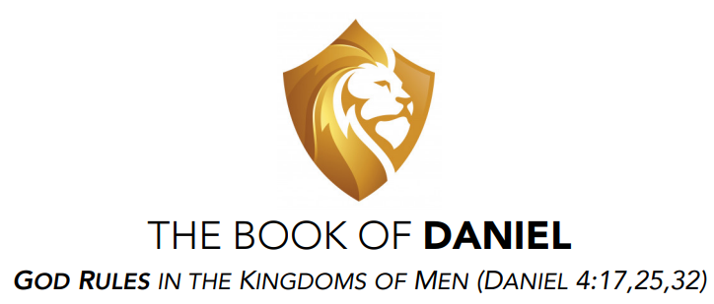

Adult Class – Wednesday Nights
April – June 2024 – Public Invited
www.nechurchofchrist.org

Daniel Schedule & Workbook

Our workbook this quarter is from Phillip Shumake & Wayne Gaskin, members at the Embry Hills church of Christ in Atlanta, GA. Their website includes MANY helpful class workbooks. https://embryhills.com/listen-study/adult-class-material

God Rules in the Kingdoms of Men (Daniel 4:17, 25, 32)

Class Goals:
Kingdoms: To better understand God’s ultimate authority over the rise & fall of nations.
Prayer: To improve our prayer life by learning great prayer habits from Daniel.
Character: To develop & exercise the faith & moral characteristics of Daniel & his friends.

Date: Lesson: Text:
April 10 1) Daniel’s Captivity & Conviction Ch 1
April 17 2) Daniel Interprets Nebuchadnezzar Dream Ch 2
April 24 3) Daniel’s Friends Face the Fiery Furnace Ch 3
May 1 4) Nebuchadnezzar Is Shown God’s Rule Ch 4
May 8 5) Daniel Interprets at Belshazzar’s Feast Ch 5
May 15 6) Daniel Faces The Lions’ Den Ch 6
May 22 7) Daniel’s Vision of Coming Kingdoms Ch 7
May 29 8) Daniel’s Vision of Medo-Persia & Greece Ch 8
June 5 9) Daniel’s Prayer for the People’s Return Ch 9
June 12 10) Daniel’s Vision of Israel’s Difficult Future Ch10-11
June 19 Substitute Topic TBA TBA
June 26 11) Daniel’s Vision of The End of Days Ch 12
July 3 13) Special Study: Daniel & Error of Premillennialism
Extra Lesson for personal use: Daniel & The Revelation

Timeline & Pre-Course Quiz by Martin Broadwell & Danny Haynes
